I am pleased to help Choral Dynamics continue its mission of Helping Our Community Through Song!

ENCLOSED IS MY TAX DEDUCTIBLE GIFT FOR $___________________(Check payable to Choral Dynamics)

Levels of Giving

_____ Diamond ($1000 +) _____ Platinum ($200-999) _____ Gold ($250-499)
_____ Silver ($100-249) _____ Bronze ($50-99) _____ Pewter ($25-49)

Name as you would like it listed in the program:

________________________________________________________________________________________________________

Email Address____________________________________________________________________________________________

Address _______________________________________________________ Phone ______________________________

City, State ______________________________ Zip Code ____________ Date _______/_______/_______

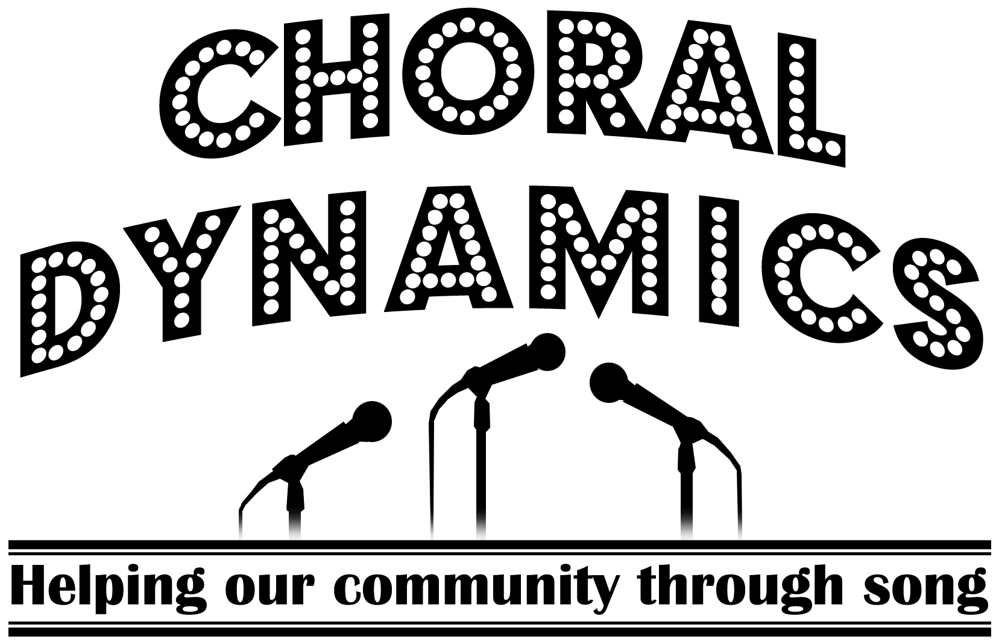
P.O. Box 432
Galesburg, IL 61401

